### CHALLENGE 3

1. Create docker-compose.yaml with code
2. version: "3"
3. services:
4. nginx:
5. image: nginx:latest
6. build: ./docker/nginx
7. ports:
8. - "8080:80"
9. depends_on:
10. - node-service
11. node-service:
12. build: ./docker/api
13. ports:
14. - "3000:3000"
15. environment:
16. - DB_HOST=${DB_HOST}
17. - DB_USERNAME=${DB_USERNAME}
18. - DB_PASSWORD=${DB_PASSWORD}
19. - DB_DATABASE=${DB_DATABASE}
20. depends_on:
21. - db
22. db:
23. image: mysql:latest
24. ports:
25. - "3307:3306"
26. environment:
27. - MYSQL_ROOT_PASSWORD=${MYSQL_ROOT_PASSWORD}
28. - MYSQL_DATABASE=${MYSQL_DATABASE}
29. - MYSQL_USER=${MYSQL_USER}
30. - MYSQL_PASSWORD=${MYSQL_PASSWORD}
31. volumes:
32. - db-data:/var/lib/mysql
33. command: --default-authentication-plugin=mysql_native_password
34. volumes:
35. db-data:

2. Edit docker/api/Dockerfile

# Use the official Node.js image as base

FROM node:alpine

# Set the working directory in the container

WORKDIR /app

# Copy package.json and package-lock.json

COPY package*.json ./

# # Install dependencies

RUN npm install

# Copy the rest of the application

COPY * .

# Expose port 3000 to the outside world

EXPOSE 3000

# Command to run the application

CMD ["node", "server.js"]

# CMD ["sleep", "infinity"]

3. Create .env file inside challenge3 folder

# APPLICATION CONFIG

DB_ROOT_PASSWORD=root

DB_DATABASE=challenge3

DB_USERNAME=anthony

DB_PASSWORD=password

DB_HOST=db

# DATABASE CONFIG

MYSQL_ROOT_PASSWORD=root

MYSQL_DATABASE=challenge3

MYSQL_USER=anthony

MYSQL_PASSWORD=password

MYSQL_HOST=db

4. Run in command docker-compose up --build

* 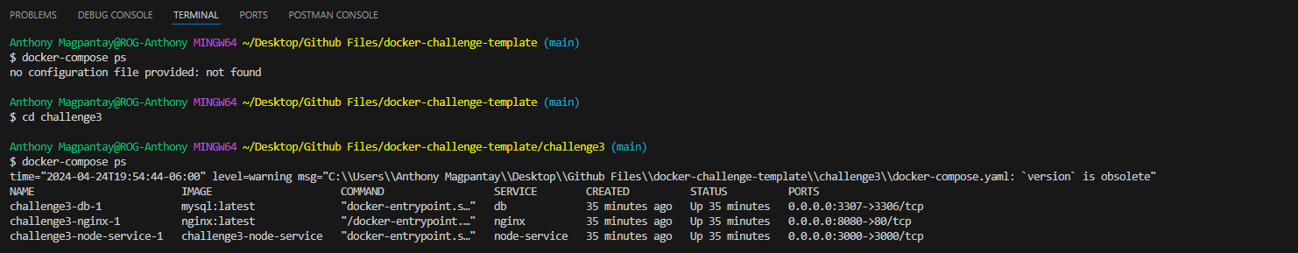Result of docker-compose ps
* A screenshot of a computer

  Description automatically generatedScreenshot of Docker

REFERENCES

<https://www.youtube.com/watch?v=1je3VxDF67o>

### CHALLENGE 4

* Before Scaling

Hostname: 4057c906bbe8

* Command to scale

docker-compose up --scale node-service=3

* After Scaling

Hostname: 084e4bbdb924

Hostname: b3a342771bdc

Hostname: 06ea8f93668c

* A screen shot of a computer

  Description automatically generatedResult of docker-compose ps
* 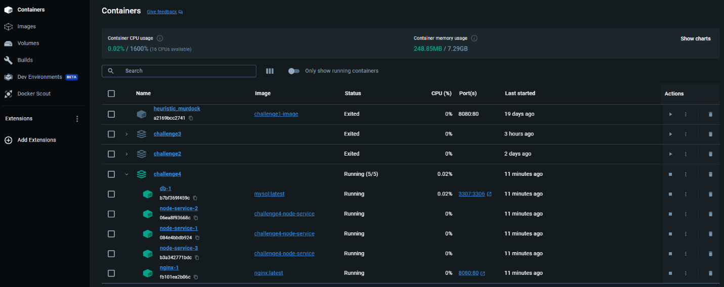Screenshot of Docker

REFERENCE:

https://www.appsdeveloperblog.com/scaling-with-docker-compose-a-beginners-guide/